 

ASSIGNMENT ON INTERNET TECHNOLOGY(IT)

Assignment Weightage & Type

60% Portfolio Coursework

Corse: BSc (Hons) CS & DF (Sem_2)

**NAME: AMAN YADAV**

**STUDENT ID: 10722**

**WEEK 5**

EXERCISE 1

Write the HTML code which use of:

▪ The italics tag

▪ The Center tag

▪ The paragraph tag

▪ The Break tag

▪ The Font tag and its attributes

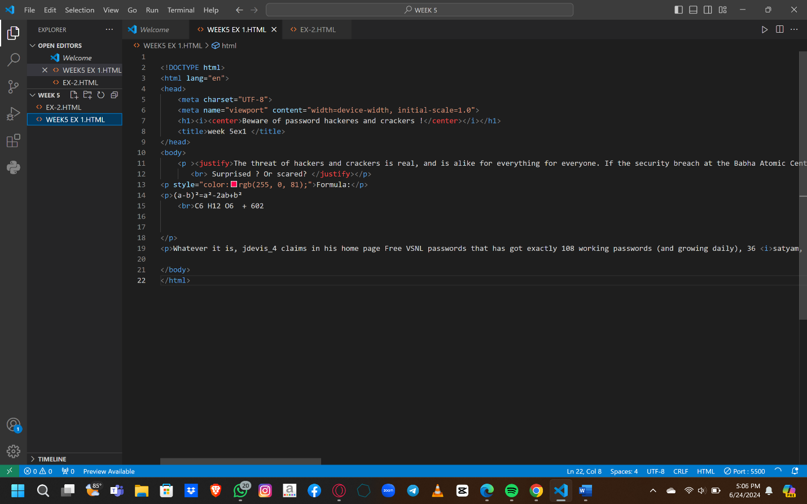

**OUTPUT:**

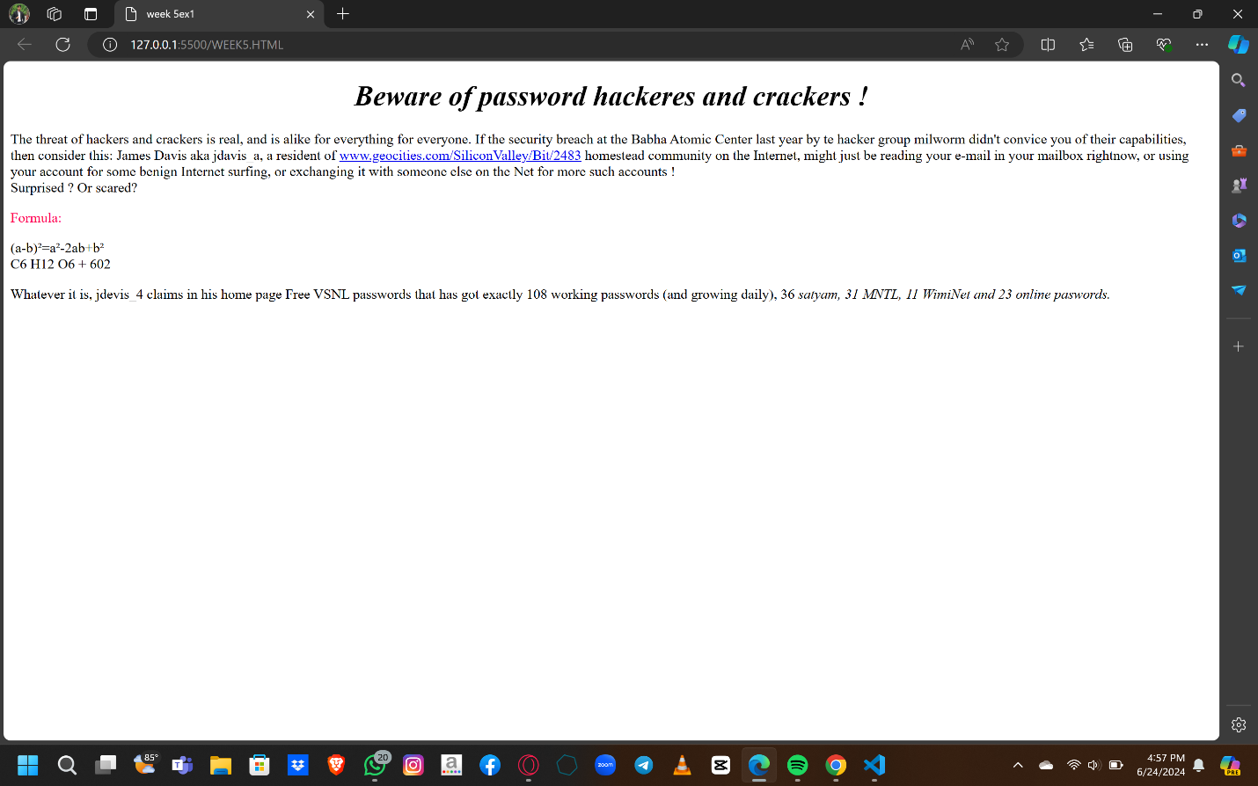

EXERCISE 2

2. Looking at the screen given below write the HTML code making use of following tags

* Unordered Lists
* Ordered Lists
* Definition Lists
* Heading tag

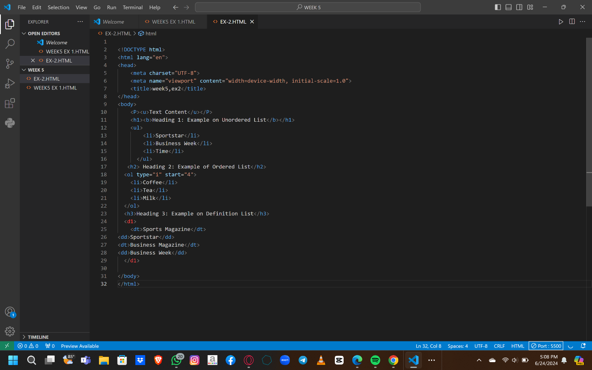

**OUTPUT:**

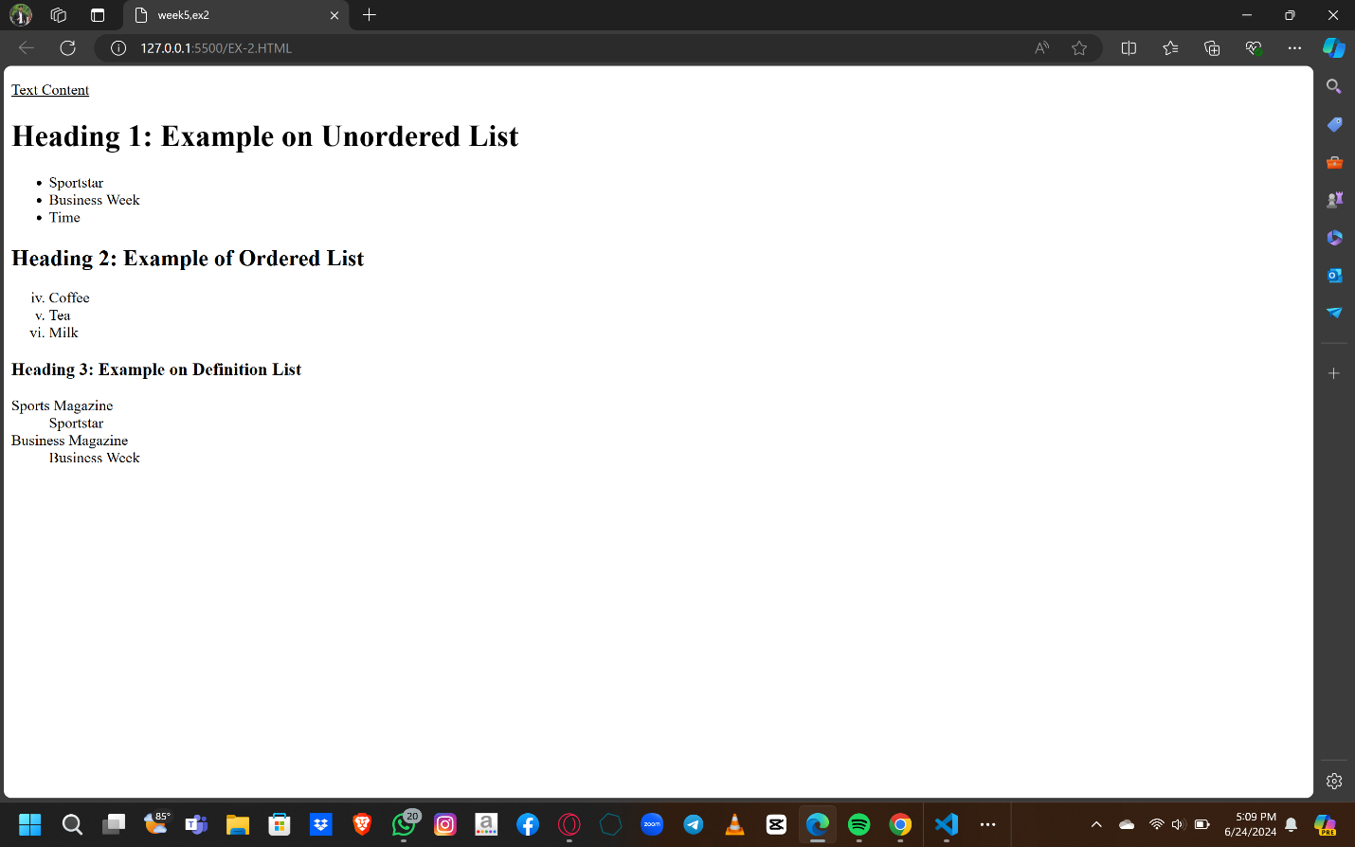

EXERCISE 3

Design a two web page according to the following specifications.

**Page 1 detail:**

Use “landscape.jpg” image as page background and display the content on top of it. Text

content should visible, background image should not affect the text content.

**Page 2 detail:**

Use “BLACK color” as background color and display text content on top of it using

“WHITE color”

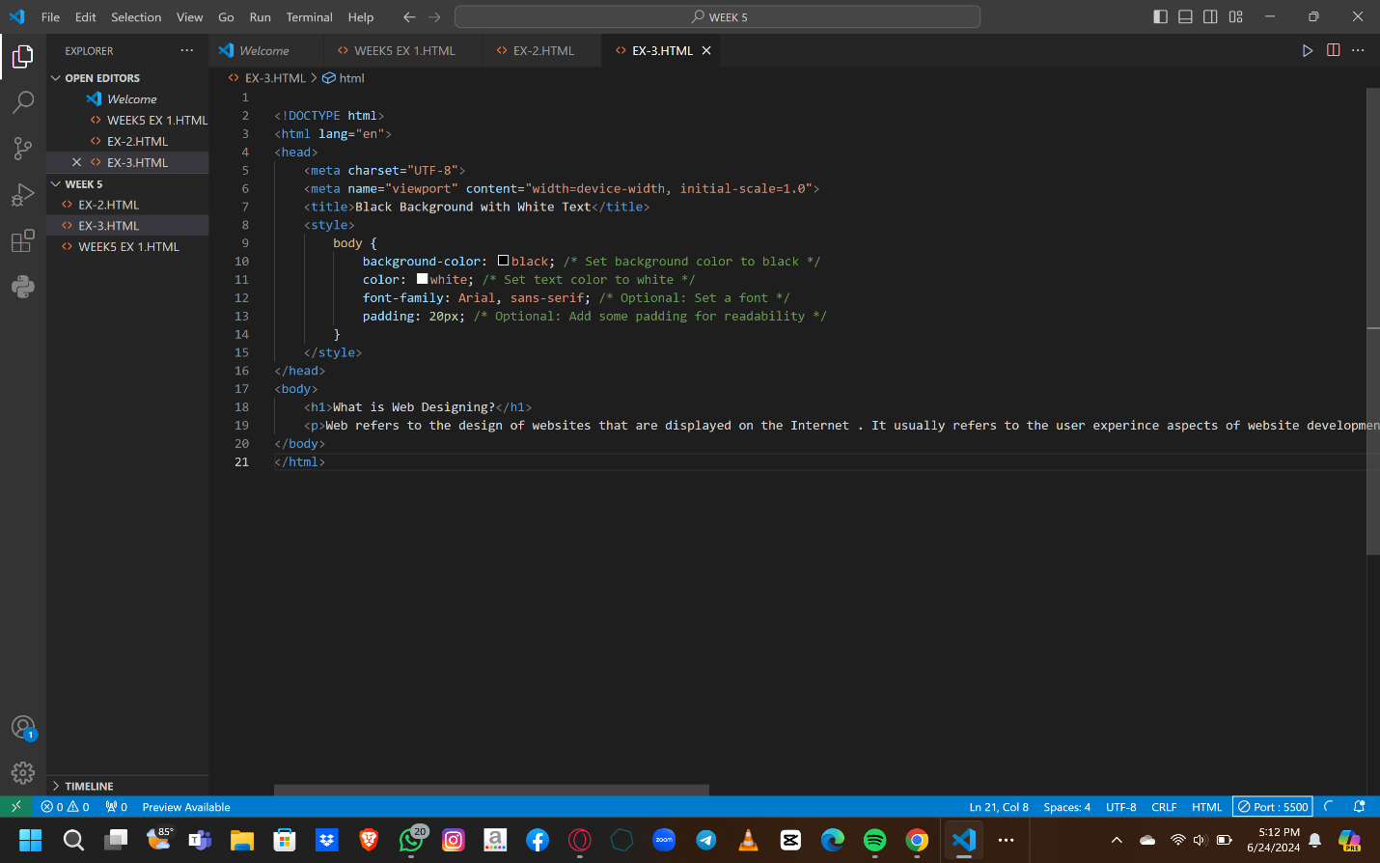

**OUTPUT:**

